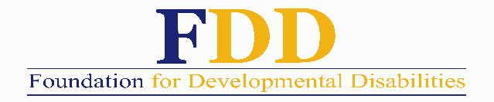
PETERSON SCHOLARSHIP APPLICATION 2023
**Application MUST be received by NOON April 7th, 2023**

NAME (please print) _______________________________ STUDENT ID# ___________________

ADDRESS ________________________________________ CITY _________________ ZIP _______

TELEPHONE NUMBER ( )_________________________ E-MAIL __________________________

DATE OF BIRTH ___________________________________ CITIZENSHIP ______________________

Name of Parents, their address, occupation (s) and employer (s):

MOTHER:

FATHER:

NAME OF COLLEGE YOU ATTEND OR PLAN TO ATTEND: _______________________________________

RECENT GPA: __________

Describe your education goals: Please type in your responses in a separate word document and submit with your application.

Describe past work experience: Please type in your responses in a separate word document and submit with your application.

Funds of the Peterson Scholarship are to be used for the educational purposes of worthy, talented, industrious men and women who are planning a career or are presently working in a child development program, the field of developmental disabilities, or related fields. Scholarships are available for students who are residents of San Diego and/or Imperial County and who plan to remain in the area to work. To be eligible for scholarships, applicants must demonstrate a financial need. The Peterson Scholarship Committee continues to accept and give priority to qualified first and second grant applications. The committee may also accept, review, and award grants to selected students who have had two previous grants. Further requests for grants from a student will not be considered if their survey has not been returned.

In addition to the completed application, please submit the following required information:
- A one-page letter describing how you plan to make a difference and indicating why you believe you qualify for this scholarship.
- Two letters of professional recommendation; and
- A college transcript (does not need to be a certified copy).

All finalists will be interviewed.

Deadline: Application must be received by the Foundation for Developmental Disabilities at the address below by NOON on April 7th, 2023. You may also email to: mail@foundationfordd.org

SUBMIT TO: FOUNDATION FOR DEVELOPMENTAL DISABILITIES
Attn: Peterson Scholarship 6050 Santo Road Ste. 145, San Diego, Ca 92124

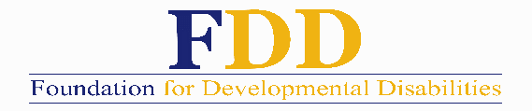

FINANCIAL STATEMENT OF APPLICANT

YEARLY INCOME YEARLY EXPENSES

Employer Name _________________________
Wages $ ____________ Tuition $ __________
Family Assistance $ ____________ Rent $ __________
Food $ __________
Living Expenses $ __________
Installment Pmts. $ __________

Other Income (describe) Other Expenses (describe)
______________________ $ __________ _________________ $ __________
______________________ $ __________ _________________ $ __________
______________________ $ __________ _________________ $ __________

TOTAL INCOME $ __________ TOTAL EXPENSES $ __________

ASSETS

Cash $ __________ Student Loans (describe)
Savings $ __________ _________________ $__________
Checking (Average Balance) $ __________ _________________ $__________
Auto ___________________ $ __________ _________________ $__________
Year/Make
Other Assets (describe)
_______________________ $ __________
_______________________ $ __________

TOTAL ASSETS $ __________ TOTAL EXPENSES $ __________

SUMMER EMPLOYMENT PLANS
Please type in your responses in a separate word document and include with your application.

Indicate the amount of financial assistance you are requesting: $ ______________

Additional Comments:
Please type in your responses in a separate word document and include with your application.

Date: ____________________

Signature of Applicant ____________________________________

